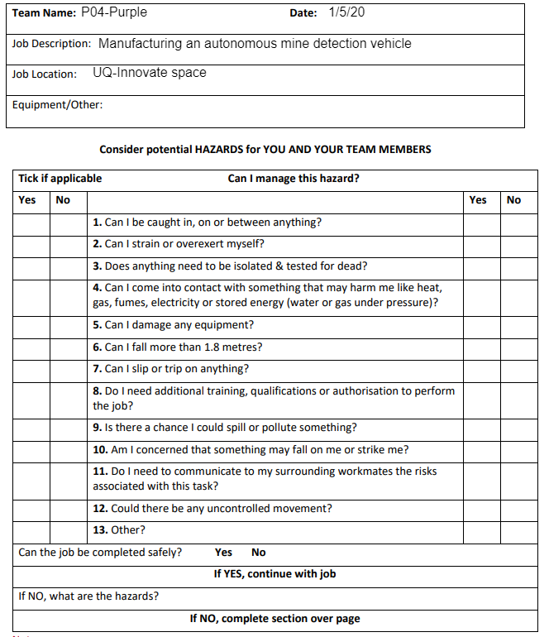

Electrocution, burns, getting caught in or damaging a machine by misuse

Various saws, drill press, screwdrivers, 6” vice, electrical components, mallets/hammers, clamps, soldering iron. PPE: Enclosed shoes and eye protection

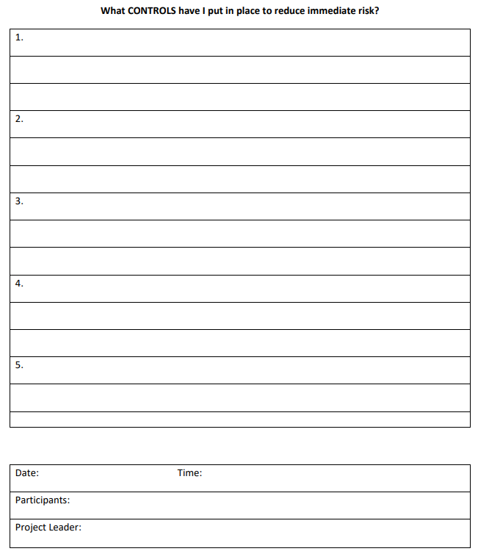

Sara

Lachlan Edwards, Abhishekh Jeyadev, Joseph Churchill, Luke Mayer

2:00PM

01/04/20

Ensure you have been properly trained to use the given equipment, and if not, then seek training from a supervisor before using the equipment.

Damaging equipment through misuse due to lack of training.

Be aware of and consider the potential risks in using the machine

Wear appropriate PPE; ask a supervisor whether further training is required before operating a machine you are unfamiliar with

Getting caught in a machine due to lack of training or caution

Wear appropriate PPE to protect from electrocution/burns while handling electrical components and soldering iron. E.g thermally and electrically insulated gloves

Electrocution